OMCI and PLOAM Implementer’s Guide
May 30, 2008

1 Scope 3
2 References 3
3 Definitions 3
4 Abbreviations and acronyms 3
5 Conventions 3
6 Basis for Document 3
7 OMCC Best Practices 3
7.1 Encryption 5
8 Equipment management 5
8.1 ONT Bring-up 5
8.1.1 New ONT Bring-up 5
8.1.2 Old ONT Bring-up 8
8.2 MIB and Alarm Synchronization 11
8.2.1 MIB Synchronization 11
8.2.2 Alarm synchronization 18
8.3 Discovery 22
8.3.1 Discovery of ONT physical capabilities – MIB UPLOAD 22
8.3.2 Discovery of ONT software capabilities -- OMCI Capability Report 22
8.4 Software Image Download 24
8.4.1 Composition of Software Image 25
8.4.2 Download 25
8.4.3 Commit and Activate 25
8.5 Circuit Packs 29
8.5.1 The slot-port model 29
8.5.2 The chassis-based ONU 31
8.5.3 Dynamic behaviour 32
8.5.4 Protection 37
8.5.5 Environmental inputs and outputs 37
8.5.6 Managed entity analysis 37
8.6 Remote Debug 41
8.7 Message flow 43
8.7.1 Success Example 43
8.7.2 Failure Examples 43
8.8 Power Shedding 45
8.8.1 State Diagram 47
9 Layer 2 Data Service 47
9.1 Requirements Base 47
9.2 ANI Management 48
9.2.1 ANI Requirements Summary 48
9.2.2 ANI Data Model 48
9.2.3 ANI Operation 48
9.3 Layer 2 Unicast Data Services 48
9.3.1 Unicast Requirements Summary 48
9.3.2 Service Delivery Provisioning Models 49
9.4 Layer 2 Multicast Data Services 49
9.4.1 Multicast Requirements Summary 49
9.4.2 Service Delivery Provisioning Models 49
10 Layer 3 Data Services 49
11 Ethernet Services 49
12 802.11 Services 49
13 xDSL Services 50
14 TDM Services 50
14.1 CES 50
15 Voice Services 50
15.1 VoIP Media Provisioning 50
15.2 SIP OMCI Provisioned 50
15.3 SIP Non-OMCI Provisioned 50
15.4 H.248 OMCI Provisioned 50
15.5 H.248 Non-OMCI Provisioned 50
16 MoCA 50
17 Traffic Management 50
18 Alarms and AVCs 50
19 Test Processing 50
20 Performance Monitoring 51
21 RF Overlay and Return 51
22 Vendor Specific Object Handling 51
23 For Future Study 51

Summary
This document is an informative section for the 984.4 standard, aimed to clarify GPON provisioning and management related aspects and enable easier interoperability. The document includes suggested best practices for implementing the ONT management and control interface.
Source
Keywords
G-PON, Implementers’ Guide, OMCI

Introduction
This Implementers’ Guide describes best practices for interoperability between the GPON OLT and ONU in the management plane. As such, it attempts to provide a foundation that promotes interoperability between equipment from all GPON vendors.

Scope
The purpose of this document is to clarify descriptions on ITU-T Recommendation G.984.4. The Implementers’ guide does not request any modifications for the recommendation, but provides comments and clarifications on the recommendation to enhance readability for implementers.

In the course of describing the establishment of the ONT Management and Control Channel (OMCC), this document touches on some aspects of PLOAM usage described in G.984.3. However, the remainder of the document confines itself to aspects of G.984.4.

References

Definitions

Abbreviations and acronyms

Conventions

Basis for Document
This guide uses the requirements presented in G.984.4 version TBD as the basis for the MIB assumed for an ONU. In addition, it uses the requirements contained in DSL Forum WT156 and WT167 (** TBD Change to TR!!!**) as the basis for the data service capabilities that are provided by an ONU.

OMCC Best Practices
This section contains a description of the best practices associated with the ONT Management and Control Channel (OMCC).

A newly active ONU autonomously creates a T-CONT ME instance for each T-CONT that is supported by the ONU. Upon creation, all T-CONT ME instances are unassigned (Alloc-ID = 0xFF). The ONU also creates the internal OMCC structure that contains an OMCI queue, a placeholder for an Alloc-ID attribute, and a placeholder for an OMCI Port-ID attribute. The OMCC structure (a virtual "OMCI T-CONT") is not represented in the MIB.

The establishment of the OMCC should follow the process as shown in Figure 7.1 OMCC Best Practices. During the activation, the ONU receives a PLOAM message from the OLT indicating the assignment of the ONU-ID. The ONU should then populate the Alloc-ID attribute of its OMCC structure with the ONU-ID. This makes the Alloc-ID for OMCI used by the ONU the same as the assigned ONU-ID. Upon completion of ONU ranging, the OLT should assign to the ONU the GEM Port ID for carrying the OMCI messages. This is accomplished by a Configure_Port-ID PLOAM message. The ONU populates the OMCI Port-ID attribute of the OMCC structure based on that message, and responds back to the OLT with an acknowledgment. At this point, the OMCI path has been successfully established.

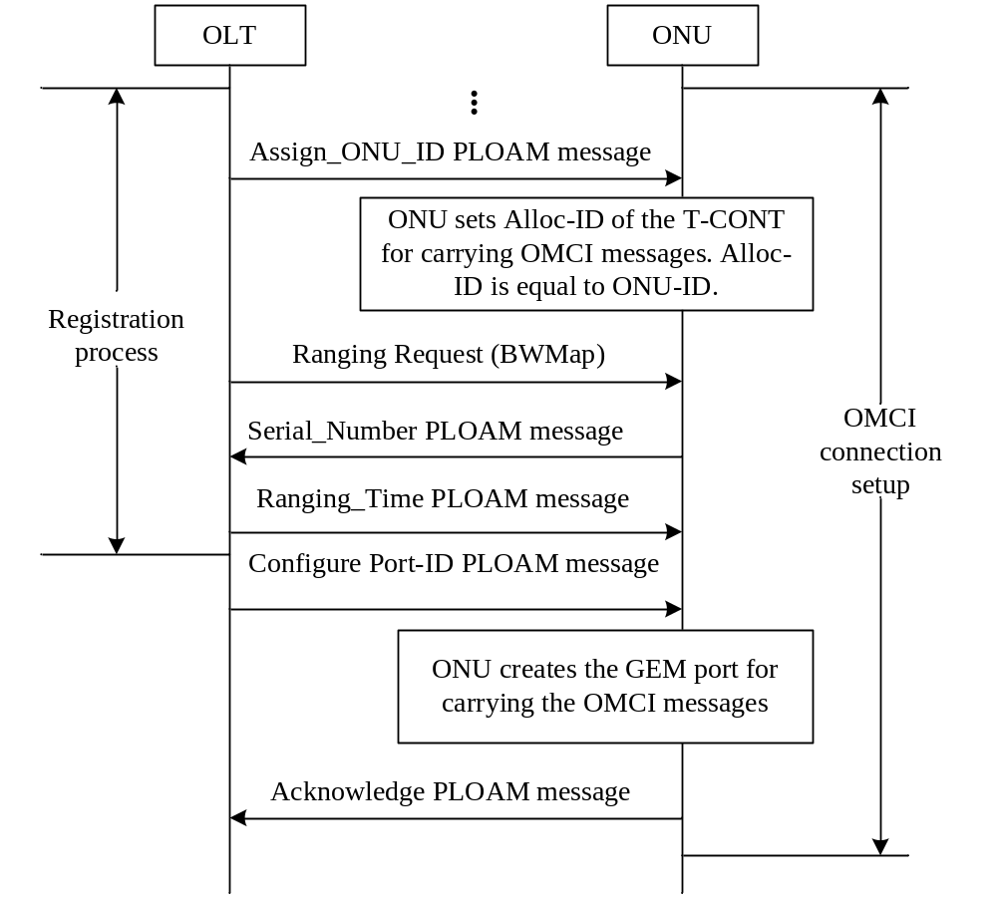
Figure 7.1 OMCC Best Practices

Since the Assign_ONU-ID PLOAM message also assigns a numerically identical Alloc-ID by default, it is not necessary for the OLT to use an Assign_Alloc-ID message in order to assign the default Alloc-ID to the ONU (i.e., the Alloc-ID equal to the ONU-ID). If the OLT nevertheless chooses to send an Assign_Alloc-ID PLOAM with the default Alloc-ID, the ONU shall acknowledge this message without taking any specific further action. The latter is true regardless of the Alloc-ID Type value in the Assign_Alloc-ID message: it should not be possible to de-allocate the default Alloc-ID with an Assign_Alloc-ID Type 255 message.

Encryption
After the OMCC has been established, it is possible for the OLT to enable encryption on the OMCC GEM port. This is accomplished by the OLT sending the ONU an Encrypted Port ID PLOAM identifying the GEM port for OMCC that was previously provisioned in the ONU by the OLT.

Equipment management

ONT Bring-up
ONT Bring-up is separated into two distinct processes: New ONT Bring-up and Old ONT Bring-up. The definition of new ONT vs. old ONT is based on the status of the ONT as viewed by the OLT:

New ONT: The ONT has never completed the OLT’s MIB synchronization. For instance:

- The ONT has never been connected to the OLT and the OLT never “saw” its serial number.
- The ONT has been connected to the OLT but OLT did not assign an ONU-ID to it.
- The ONT has been provisioned but later de-provisioned by OpS.
- The ONT has failed MIB synchronization due to MIB corruption.

Old ONT: The ONT has been connected to the OLT, assigned the ONU-ID, and completed MIB synchronization at least once.

New ONT Bring-up
The bring-up process for new ONTs should be followed as shown in Figure 8.2 New ONT Bring-up. After the ONT powers up, and begins execution of a valid software version, the ONT automatically creates its MIB. Refer to G.984.3 for a more detailed explanation of state transitions during the activation process. Once the ONT transitions to Operation-state (O5), the OLT creates the OMCC as described in section 7 OMCC Best Practices. Initially, the OLT sets the ONT MIB to its default state by sending a MIB reset to the ONT. Once the ONT receives this message, it re-initializes its MIB to default values, and resets the MIB data sync counter to zero. Next, the OLT sends a MIB synchronization command, uploads the ONT MIB, and retrieves all ONT instances and capabilities. The OLT then downloads MIB updates to the ONT to bring the ONT MIB in synch with the OLT MIB.

In general, the use of Attribute Value Change (AVC) messages should be viewed as a partial method of ONT discovery. The OLT cannot solely rely on the receipt of AVCs to learn all ONT information since not all managed entities or attributes issue AVCs, and AVCs can be lost in transmission without an error being detected. Therefore, the OLT should audit any ONT immediately after a reset is completed.

When an ONT changes an attribute value autonomously, it sends an AVC message to OLT. The ONT can send AVC messages during MIB synchronization or MIB download processes.
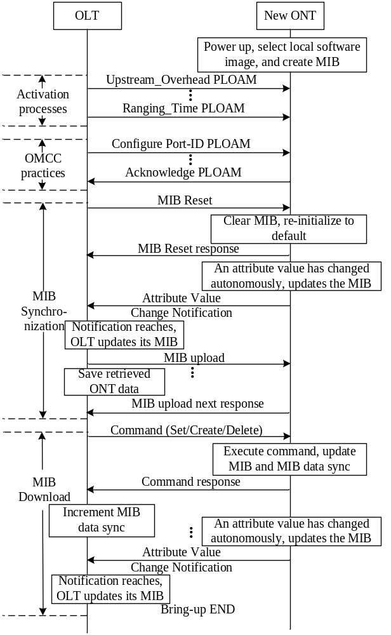

Figure 8.2 New ONT Bring-up

Old ONT Bring-up
The old ONT bring-up process should be followed as shown in figures Figure 8.3 Old ONT Bring-up case 1 – ONT MIB data sync matched and Figure 8.4 Old ONT Bring-up case 3 – ONT MIB data sync mismatched.

After the ONT powers up, and begins execution of a valid software version, the ONT automatically creates its MIB. Refer to G.984.3 for a more detailed explanation of state transitions during the activation process. Once the ONT transitions to Operation-state (O5), the OLT creates the OMCC as described in section 7 OMCC Best Practices. The OLT then retrieves the ONT data sync by sending a Get[ONT_Data] message to ONT, and the ONT responds with a Get_response[ONT_Data] message. After receipt of the ONT’s data sync value, the OLT compares the received value to the OLT’s data sync value for that ONTs MIB.

The result of the comparison will lead to three possible ONT bring-up scenarios:

If the ONT MIB data sync value matches with OLT’s but is not equal to zero, the OLT assumes that their MIBs are in alignment. The MIB data on both sides of OLT and ONT are identical. The ONT bring-up process is completed.

If the ONT MIB data sync value equals zero (possibly the result of an ONT software upgrade or the ONT considering its MIB to be invalid), the OLT follows the same Bring-up sequence as described for a New ONT (above).

If the ONT MIB data sync value did not match, the OLT executes the MIB synchronization process. The sending of a MIB reset message is optional. Refer to 8.2 (MIB and Alarm Synchronization) for more details. To align MIB data sync, the OLT sends a Set[ONT_Data] command to complete the bring-up process. If the ONT failed MIB synchronization due to MIB corruption during ONT bring-up, the OLT should re-synchronize the ONT as shown in Figure 8.2 New ONT Bring-up.
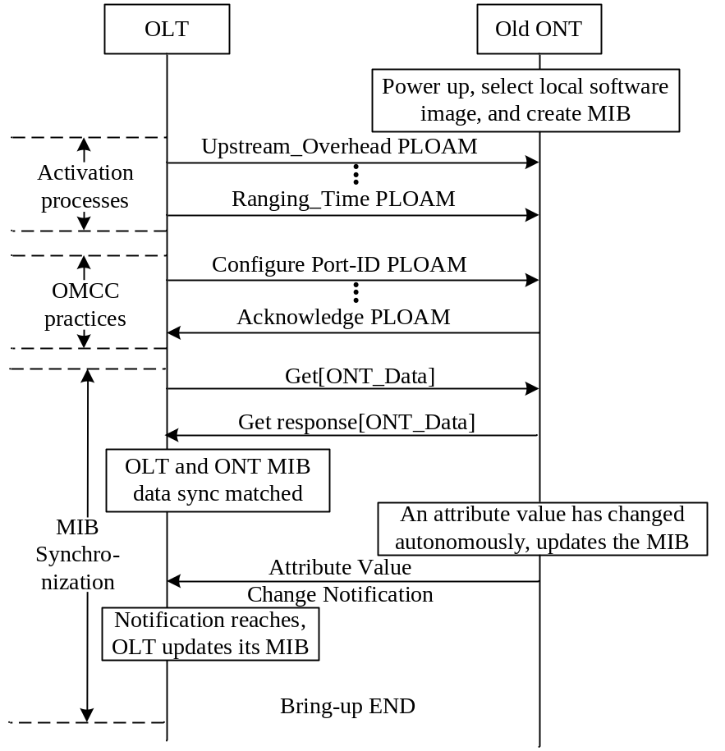

Figure 8.3 Old ONT Bring-up case 1 – ONT MIB data sync matched

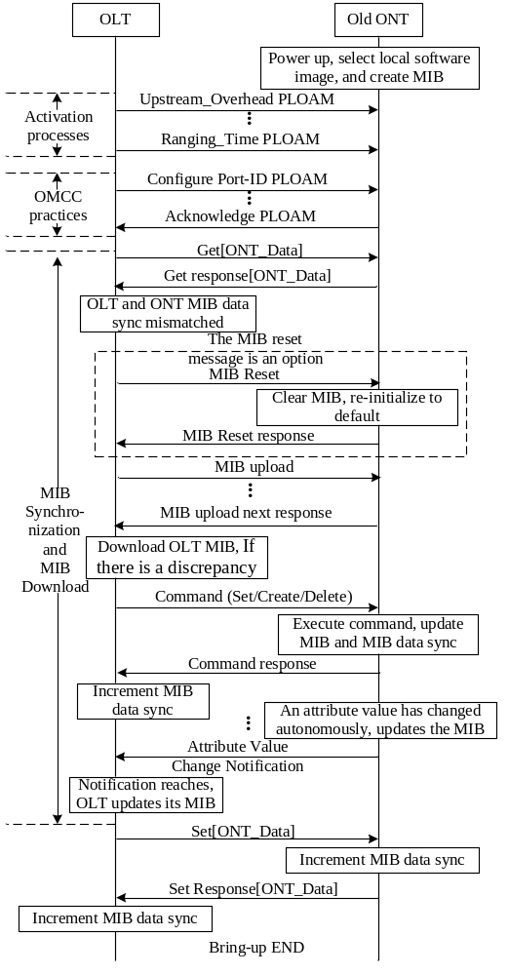
Figure 8.4 Old ONT Bring-up case 3 – ONT MIB data sync mismatched

MIB and Alarm Synchronization

MIB Synchronization

MIB data sync attribute
It’s essential to the correct operation of the GPON system to keep the MIB synchronized between the OLT and ONU at all times. As defined in G.984.4, the generic "tool" used for achieving this is the MIB data sync attribute of the ONT Data managed entity. The MIB data sync attribute is a global 8-bit sequence number. When auditing the MIB in the ONT, the OLT requests this sequence number. If this number is equal to the sequence number in the OLT, no further action is needed, as the copy of the MIB, in ONT and the copy of the MIB in the OLT, are considered to be identical. However, the MIB data sync attribute does not reflect the state of the entire MIB so it is important to understand the operation of the MIB data sync attribute.

MIB data sync operations
The MIB data sync attribute is incremented for the creation and deletion of managed entity instances that are the consequence of a command by the OLT. The MIB data sync counter is also incremented for attribute value changes which are the consequence of a command by the OLT. The MIB data sync counter is incremented once per executed command not once per attribute impacted by a command (Figure 8.5 Increment of MIB data sync at ONT and OLT under OLT command).
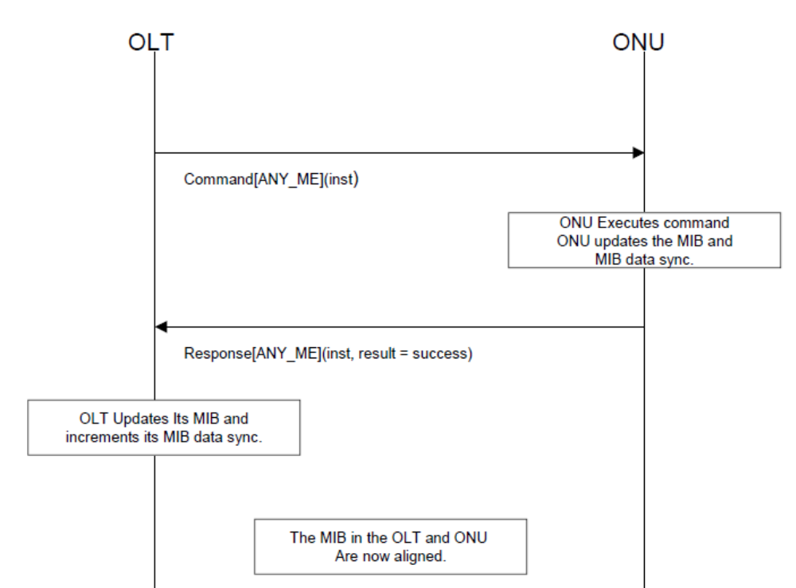
Figure 8.5 Increment of MIB data sync at ONT and OLT under OLT command

In contrast, the MIB data sync counter is not incremented for autonomous creation and deletion of managed entity instances by the ONT itself. Neither is the MIB data sync counter incremented for autonomous changes to attributes of managed entities within the ONT (Figure 8.6 No increment of MIB data sync at ONT and OLT).

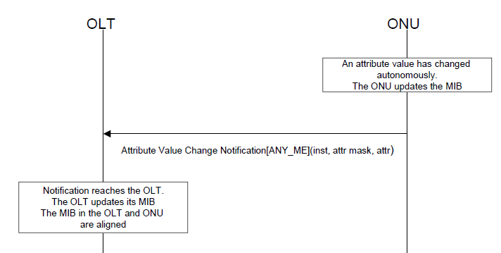
Figure 8.6 No increment of MIB data sync at ONT and OLT

For the off-lined ONT case, the OpS sends a command (create/delete/set) to ONT, the OLT saves these MIBs only on the OLT side and increments the MIB data sync, but does not send the command to ONT. In other words, the OLT should only locally update the MIB and increment the MIB data sync so that it guarantees that when the ONT comes on-line, the MIBs audit will fail.

The order in which the OLT and the ONT update their MIBs and increment the MIB data sync attribute is not imposed by G.984.4. Regardless of the order chosen, both the OLT and the ONT must locally update the MIB and increment the MIB data sync as one atomic action. However, it is considered good practice for the OLT to not increment its data sync counter until it has received a positive acknowledgement to the command that it sent to the ONT.

When incremented, the sequence number that follows 255 is 1. Zero is reserved for the following cases:

- Default MIB with which the ONT left the factory.
- An ONT which after (re-) initialization cannot restore its MIB.

In other words, a sequence number of 0 indicates that the ONT’s MIB is not well defined, and therefore requires audit / reconfiguration.

Note that no mechanisms exist to detect that an autonomous attribute value change notification has been lost. Therefore, the OLT must regularly read the values of the attributes that can change their values autonomously.

Loss of MIB synchronization
In the process of an OLT modifying the MIB in an ONU, the MIB at the OLT side could fall out of synchronization with the MIB at ONT side. Figure 8.7 The mismatch of MIBs at ONT and OLT under OLT command, shows one possible scenario for this occurring.
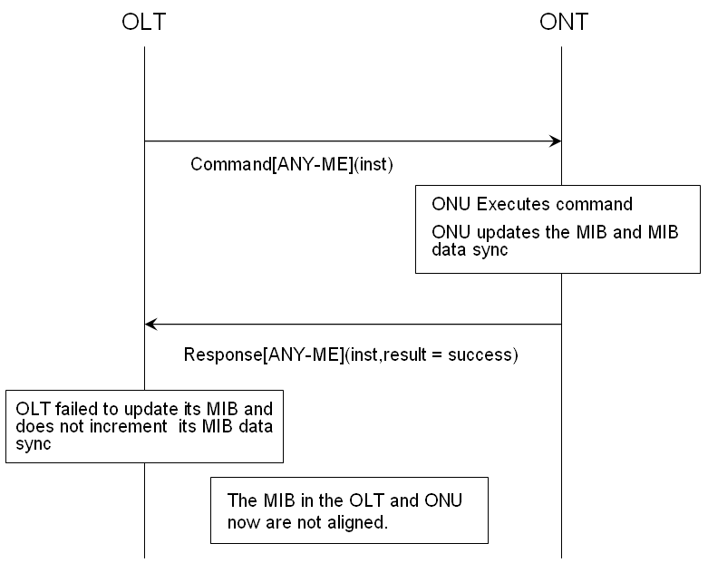
Figure 8.7 The mismatch of MIBs at ONT and OLT under OLT command
A failure in sending an AVC from the ONT to OLT will lead to a MIB mismatch. In this case, the discrepancy between OLT and ONU MIBs may not be detected by the MIB audit mentioned below. Under these circumstances, the MIB data syncs are still the same for both sides but the MIB content is no longer identical between the OLT and ONU. (Figure 8.8 The mismatch of MIBs due to lost AVC) .
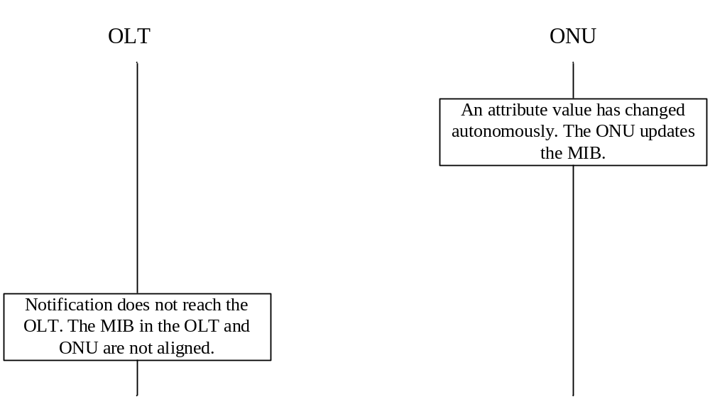
Figure 8.8 The mismatch of MIBs due to lost AVC

MIB Audit
The ONT is audited with respect to its MIB in three cases:

- On loss and re-establishment of the OMCC.
- Periodically, based on the operator's requirements.
- On demand of the OpS.

On detecting a newly installed ONT, regardless of the sequence number of its MIB, the OLT will directly perform a MIB reset and ONT bring up procedure (see section 2.1 in this guide). Figure 8.9 MIB Audit shows the scenario diagram of a MIB audit.
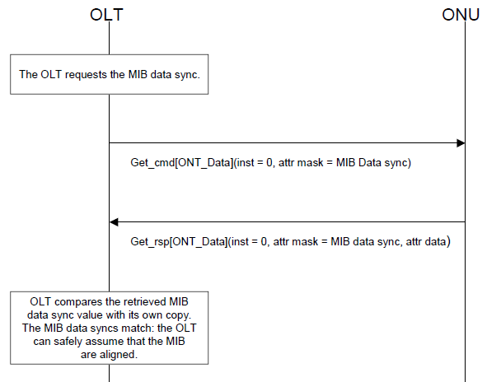
Figure 8.9 MIB Audit

MIB resynchronization
Figure 8.10 MIB resynchronization shows the scenario diagram of the MIB resynchronization process. In this case, the MIB resynchronization is the result of a MIB audit failure. Since the MIB data sync attribute does not reflect the status of the entire MIB, it is considered good practice for the OLT to periodically perform a MIB resynchronization regardless of the out come of a MIB audit.
OLT
ONU
The OLT request the MIB data sync
Get_cmd[ONT_Data]( inst = 0, attr mask = MIB data sync)
Get_cmd[ONT_Data]( inst = 0, attr mask = MIB data sync)
OLT compares the retrieved MIB data sync value with its own copy. The MIB data syncs do not match: the OLT can align the MIBs incrementally. For this, the OLT first uploads the MIB of the ONT. At this point, the OLT makes a copy of its MIB. Then the OLT will have an active MIB (A_{OLT}) and a copy (C_{OLT})
MIBupload_cmd[ONT_Data]( inst = 0 )
The ONU makes a copy of the MIB; thus the ONU will have an active MIB (AONU) and a copy (CONU). The ONU response with the indication of the number of commands (N) to be uploaded
MIBUpload_rsp[ONT_Data]( inst = 0, number of subsequent commands = N)
The OLT request the information of all instances in the MIB of the ONU. The ONU can still send AVCs and the OLT can still send configuration requests during the upload
MIBUploadNext_cmd[ONT_Data]( inst = 0, command sequence = 0 )
MIBUploadNext_rsp[ONT_Data]( inst = 0, ME class, ME inst, attr mask, attr data )
……
MIBUploadNext_cmd[ONT_Data]( inst = 0, command sequence = N-1 )
MIBUploadNext_rsp[ONT_Data]( inst = 0, ME class, ME inst, attr mask, attr data )
The OLT compares the information of received C_{ONU} to its C_{OLT} and updates the A_{OLT} or A_{ONU}.
Figure 8.10 MIB resynchronization
The OLT must issue as many MIBUploadNext requests as the number of commands given in the MIBUpload response. The maximum time between two MIBUploadNext requests is 1 minute. If the OLT does not send a MIBUploadNext request within this time after the previous MIBUploadNext request or after the MIBUpload start request, the ONT assumes the MIB upload to be terminated. The ONT can drop the copy of the MIB, and consider any MIBUploadNext requests to be out of range, as described in G.984.4.

It should be noted, that certain MEs are excluded from the MIB upload. In particular, instances of some general purpose MEs, such as the Managed Entity ME and the Attribute ME, are not included in the MIB upload. All table attributes are not included in the MIB upload. If the OLT requires this information, it obtains it on a per table basis through the use of the Get/GetNext mechanism.

Alarm synchronization

Alarm sequence number increase
The ONT informs the OLT of alarm status changes by sending alarm status change notifications. Note that these notifications are sent in unacknowledged messages that carry an eight-bit alarm sequence number for the benefit of the OLT to detect loss of alarm notifications (Figure 8.11 Increment of alarm sequence number at ONT and OLT thru Figure 8.13 No increment of alarm sequence number at ONT and OLT under ARC).

After a restart of the ONT, the alarm sequence number is reset so that the first alarm notification sent by the ONT has an alarm sequence number equal to 1. The alarm message sequence number is incremented for each alarm notification and wraps around from 255 to 1. Consequently, an alarm notification with sequence number 0x00 is never sent.

In the case of alarms under ARC, an alarm message is not sent. Therefore, the alarm sequence number is not incremented.
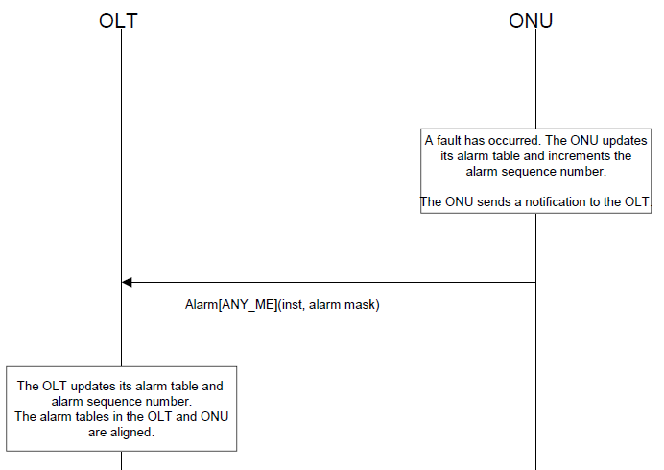
Figure 8.11 Increment of alarm sequence number at ONT and OLT
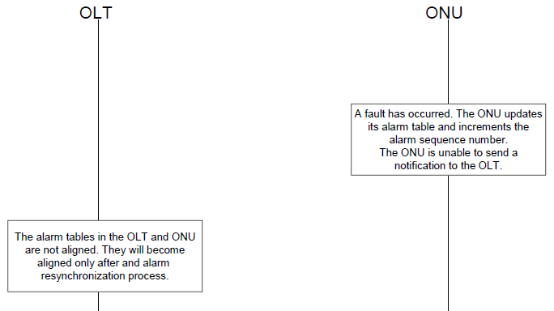
Figure 8.12 Alarm Sequence Number Fails to Stay in Sync
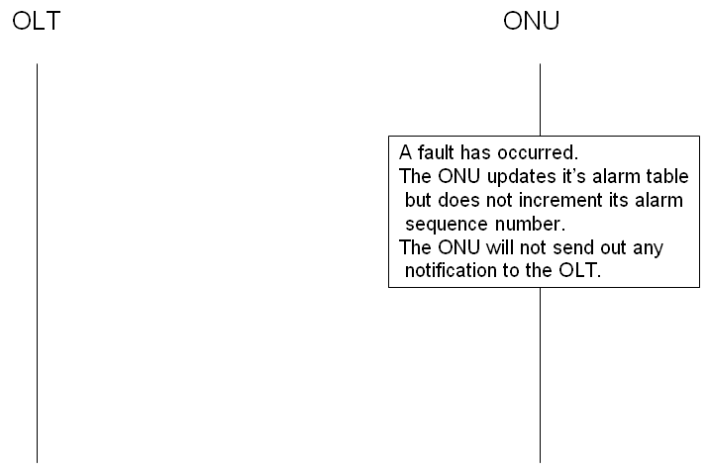
Figure 8.13 No increment of alarm sequence number at ONT and OLT under ARC

Alarm audit and resynchronization
When the OLT detects a gap in the alarm sequence number, it asks the ONT for an alarm status report by sending a "Get All Alarms" command targeted at the “ONT data” ME, as shown in Figure 8.14 Alarm Resynchronization. This command is acknowledged by a response that contains the number of managed entity instances that have outstanding alarms. The OLT then requests the alarm status of all these managed entity’s instances via the "Get All Alarms Next" command targeted at the ONT data ME. The OLT then compares the received alarm statuses with its own alarm table entries for that ONT and notifies the network manager of any changes. The alarm sequence number is reset to zero by the ONT when it receives the "Get All Active Alarms" request.

The OLT detects a missing alarm notification.
GetAllAlarms_cmd[ONT-Data](inst=0)
The ONU makes a copy of the current alarm status table of all managed entity instances, thus the ONU will have an active (A_{ONU}) and a copy (C_{ONU}) of the alarm table
GetAllAlarms_rsp[ONT-Data](inst=0, number of commands(N)) commandscommandscommand)
GetAllAlarmsNxt_cmd[ONT-Data](inst=0,cmd seq num = 0.)
GetAllAlarmsNxt_rsp [ONT-Data](inst=0,Me class, inst, alarms.)
GetAllAlarmsNxt_cmd[ONT-Data](inst=0,cmd seq num = N.)
GetAllAlarmsNxt_rsp [ONT-Data](inst=0,Me class, inst, alarms.)
The OLT copies the (C_{OLT}) populated from the GetAllAlarm sequence
The OLT processes the buffered alarms and updates its alarm table.
ONU
OLT

The ONU resets the alarm sequence number to 1 and responds to the request with an indication of the number of instances (N+1) that are required to retrieve the active alarms.

The OLT makes a blank alarm status table, thus the OLT will have an active alarm table (A_{OLT}) and a blank version (C_{OLT}). The OLT requests the alarm status using the number of commands indicated in the response.

During the Alarm Resynchronization, the ONU can still send alarm notifications. For alarms that are newly issued at this period, the OLT will buffer them temporarily and take actions after the completion of reconciliation.

Figure 2.2.2.2 − Audit and alarm resynchronization

Figure 8.14 Alarm Resynchronization

The OLT must issue as many GetAllAlarmsNext requests as the number of instances given in the GetAllAlarms response. The maximum time between two GetAllAlarmsNext requests is 1 minute. If the OLT does not send a GetAllAlarmsNext request within this time after the previous GetAllAlarmsNext request or after the GetAllAlarms request, the ONT assumes the alarm upload to be terminated. The ONT can drop the copy of the alarm table, and consider any GetAllAlarmsNext requests to be out of range, as described in G.984.4. If there’s any new alarm issued during the process of alarm upload, it is queued at the OLT side. Then after the reconciliation, OLT processes this new alarm immediately and updates its alarm table accordingly. If the OLT sets the alarm retrieval mode indicator in the GetAllAlarms command to 1, then the ONT only returns the alarms which are currently not under ARC. Otherwise, the ONT returns all alarms regardless of the ARC status.

Discovery

Discovery of ONT physical capabilities – MIB UPLOAD
When an ONU initializes, it populates its MIB with information about its equipment configuration. This should occur prior to ranging of the ONT so that the MIB provided in response to a MIB upload request reflects the current hardware configuration of the ONT. This permits the OLT to discover the hardware configuration of the ONT by analysis of the uploaded MIB.

Discovery of ONT software capabilities -- OMCI Capability Report
The GPON system should support ONU software capability reporting through the discovery of the managed entity types and message types supported by the ONU. This is accomplished through the reading of two table attributes contained within the OMCI ME.

The OLT obtains the managed entity types supported by the ONU through the managed entity type table attribute of the OMCI ME. This operation follows the procedure in Figure 8.15 ONT ME types report.
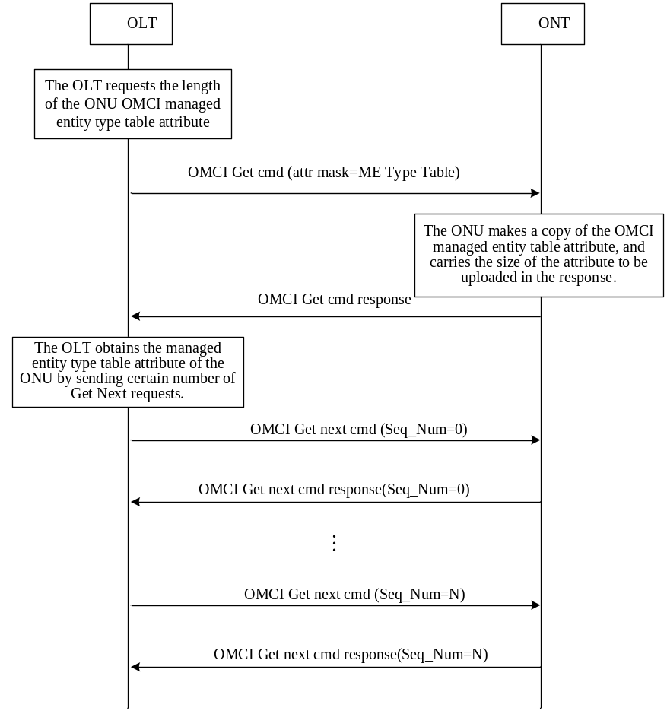
Figure 8.15 ONT ME types report

The OLT obtains the message types supported by the ONU through the “message type attribute” of the OMCI ME. This operation follows the procedure in Figure 8.16 ONT message types report.
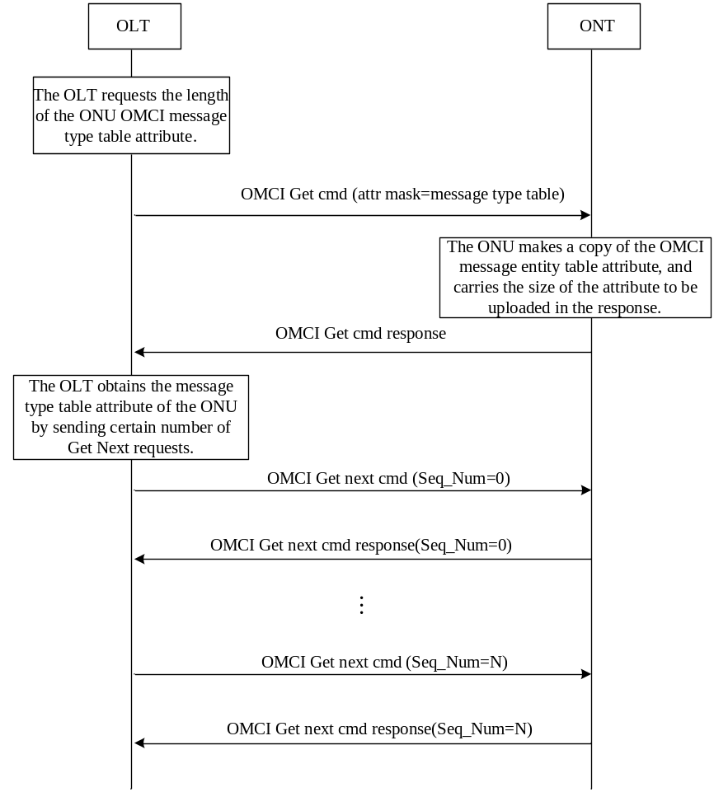
Figure 8.16 ONT message types report

Software Image Download
The ME for software download is given in clause 9.1.4 of G.984.4. For each ME which contains independently manageable software (either ONT or circuit pack), the ONT creates two software images (known as image 0 and image 1). Each image has three attributes: committed, active, and valid. An image is valid if the contents have been verified to be an executable code image. An image is committed if it will be loaded and executed upon reboot of the ONT and/or circuit pack. An image is active if it is currently loaded and executing in the ONT and/or circuit pack. At any given time, at most one image may be active and at most one image may be committed.

An ONT will go through a series of states to download and activate a software image as shown in G.984.4. Each state is determined by the status of both software images. For example, S3 is the state where both images are valid but only image 0 is committed and active. The OLT controls the state of the ONT through a series of commands also shown in G.984.4. For example, an ONT in state S3 will traverse to state S4 upon receipt of the activate(1) command. The defined commands are Start download, Download section, End download, Activate image, and Commit image.

The detailed scenario diagrams for software image download, activate, and commit are described in Figure 8.18 - Software Download thru Figure 8.20 - Software Activate and Software Commit. The message layouts for the commands are described in G.984.4.

Composition of Software Image
A software image is divided into sections of 31 bytes, with one section per OMCC message, and each section covered by the OMCC CRC. A set of sections is known as a window, and a set of windows comprises the image. The relationship between sections, windows, and the software image is shown in Figure 8.17 - Relationship between Image, Windows, and Sections.

Download
The detailed scenario diagrams for software image download are described in Figure 8.18 - Software Download and Figure 8.19 - Software Download (continued). The first step in the download process is to determine the number of sections in a window, which is known as the window size. The window size is negotiated between the OLT and the ONT. The OLT proposes a window size value (Start software download command) and the ONT selects the final value (Start software download response) which must be less than or equal to the proposed OLT value. Each section is then downloaded using the Download section command. Subsequent sections increment the “download section number” field. The first section of a window should be numbered zero. After all sections in a window have been downloaded, an acknowledgment is sent (Download section response). A negative acknowledgment (caused by an OMCC CRC failure or a missed section) will result in the entire window being downloaded again. After all windows have been downloaded, the OLT will send an End software download command containing a CRC-32 covering all windows. The ONT will check the validity of the CRC-32 and send an End software download response.

If the ONT detects an error during a section download, it should wait until the entire window has been downloaded to send a negative acknowledgement as shown in Figure 8.18 - Software Download.

A common behavior in many ONTs is to respond to an End software download command with an End software download response containing the response code “device busy.” This is because some ONTs utilize a persistent memory device which requires a longer image storage interval than a typical OMCC timeout interval. The OLT should send the End software download command at some frequency until the response is not “device busy.” The OLT should include a timeout to detect an ONT that never leaves this state.

Commit and Activate
The detailed scenario diagram for software image activate and commit is described in Figure 8.20 - Software Activate and Software Commit. Once the ONT has downloaded and validated the image, that image is initially not committed and not activated. The OLT may then send the Activate image command. After a positive acknowledgement is sent (Activate image response) by the ONT, the valid software image will be loaded and executed by the ONT without changing the committed state. The OLT may then send the Commit image command, causing the ONT to set its commit state to a one and to send a Commit image response. Note that the most recent “commit” is always the commit that is followed. The time between the phases of download, activate, and commit are not prescribed by the standard.

If after downloading, verifying and activating there is still a problem with the image that causes the ONT to fail (e.g. watchdog timers detects activation failure), then the ONT should do a soft restart to the committed image. In this way, activating prior to committing may allow for automatic failure recovery by the ONT.

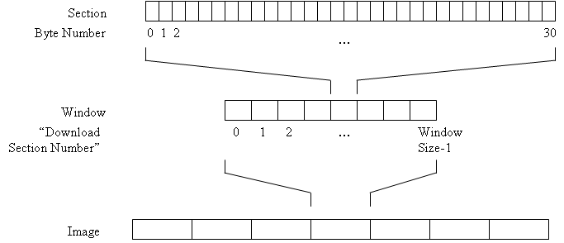

Figure 8.17 - Relationship between Image, Windows, and Sections

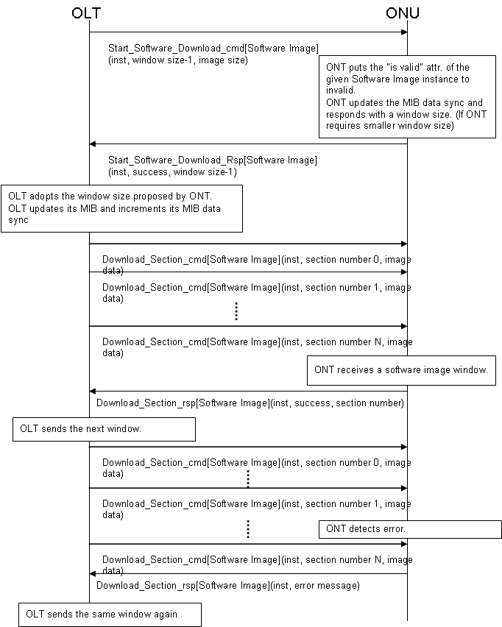

Figure 8.18 - Software Download
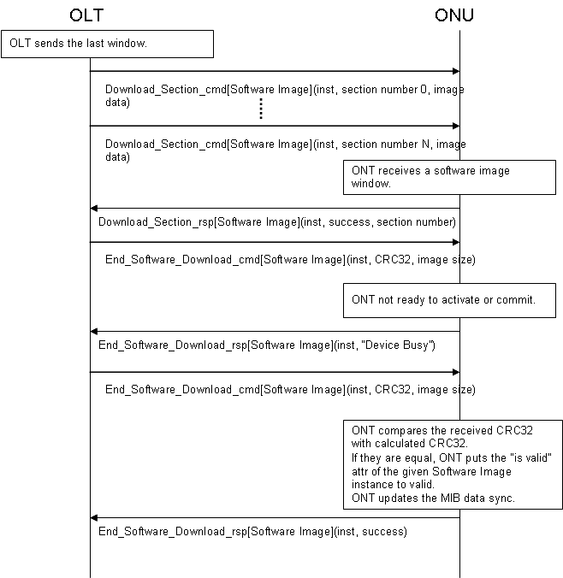

Figure 8.19 - Software Download (continued)
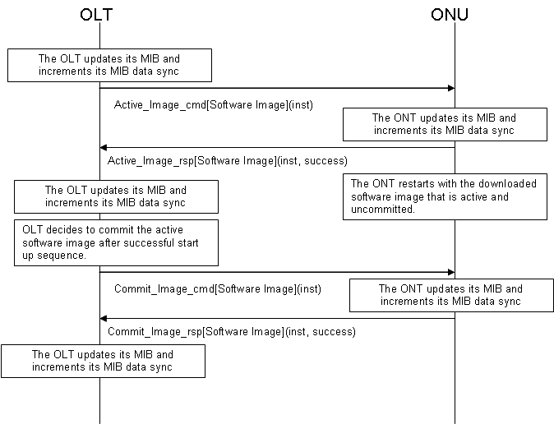

Figure 8.20 - Software Activate and Software Commit

Circuit Packs
G.984.4 appendix I.2 contains a number of clauses dealing with circuit pack provisioning. The GPON implementers’ guide replaces appendix I.2 in its entirety.

The slot-port model
ONT equipment management is modeled on a three-level hierarchy: the chassis (the ONT itself), cardholders (also known as slots), which may contain circuit packs of varying types over the course of time, and ports, which present external interfaces either to the subscriber, to the PON or to a local management tool. Many OMCI managed entities are addressed in accordance with the slot-port model. Ports – the physical termination point group of MEs – would be expected to follow this model, of course, but the T-CONT, MAC bridge service profile, IP router service profile, ARP service profile and traffic scheduler are also modelled by slot, if not by port.
All ONTs must therefore adhere to at least a minimal slot-port model. An integrated ONT is represented as a virtual chassis containing virtual cardholders. There are three ways in which this may be done.

- Several virtual cardholders may be defined, one for each interface type. This was the original model and is the most common. The more significant byte of the ME ID of a virtual cardholder has the value 1; a real cardholder has the value 0. In both cases, the slot number (actual or virtual) is the value of the less significant byte.

- A single virtual cardholder may be defined as slot 0 (LS byte), and all interfaces may be represented through the port mapping package ME, which maps ports of arbitrary types in arbitrary combinations. The port mapping package has the merit that it is universally applicable to integrated and chassis-based ONTs equipped with any type of real or virtual circuit pack, but for historical reasons, it is commonly used only when it is the only choice: a chassis-based ONU that contains circuit packs with mixed port types.

- The port mapping package may be contained by the ONT directly, rather than by a virtual cardholder. This approach has the merit that it avoids a virtual cardholder that serves no real purpose, and the disadvantage that it applies only to integrated ONTs. It is unlikely to appear in actual practice.

In the original model, real or virtual slot numbering was segregated by PON-side (128 up) vs subscriber-side (127 down). Although this constraint is no longer specified – it was unsatisfactory for real chassis with real slots, as well as mixed-function circuit packs – many existing virtual-slot implementations continue to follow this convention for historic reasons.

In addition, the two most significant bits of the slot address are available to designate xDSL bearer channels when desired. While this violates orthogonality, it poses fewer problems in practice than in theory, since a space of 64 slots more than suffices for real or virtual cardholders. Best practice would indicate that slot numbers be unique within their 6 LSBs, particularly if there is any possibility that xDSL bearer channels may need to be modeled.

As to port addressing, the original model specified ports numbered in increasing order, left to right, bottom to top, but this was inappropriate both for three-dimensional ONT packages with mixed ports of all types on several surfaces or edges and for chassis-based ONUs with service connections through the backplane rather than on circuit pack faceplates. Today, port addresses are expected only to start with 1 and to be unique. Small numbers in a contiguous sequence are preferred.

Finally, it is worth mentioning that nothing actually prohibits mixing port types on any card type, without benefit of the port mapping package. The combined video UNI and PON type (code point 44) even explicitly allows for differing port types. No convention exists for the numbering of such ports, configuration discovery is likely to be a problem, and best practice would avoid this option.

The chassis-based ONU
The original slot-port model was, and is, arguably adequate for integrated ONTs, where it is easy to create as many virtual cardholders as may be desirable. For chassis-based ONUs, however, a number of difficulties arise:

- The model does not readily accommodate the richness of possible service interfaces. G.984.4 defines circuit pack types, with an eye to listing all possibilities, but it doesn’t scale well. As an example, the long list of VF specials is not presently represented. See the next two bullet points as well.

- The model does not adequately represent common equipment, circuit packs with no external ports at all, for example power supply packs. G.984.4 includes a single code point for common equipment; it does not distinguish different types of common equipment.

- It has no way to flexibly model equipment with a combination of interfaces, for example, a single circuit pack with a PON interface, a craft port and an RF video port (code point 44 includes PON and RF video, but not craft). Code point 45 is defined for multi-function packs; it does not distinguish different types of multi-function packs. As mentioned above, port numbering conventions are undefined, except by way of the port mapping package.

- There were ambiguities in G.984.4, specifically between the possible mixes of 10/100/1000 Mb/s Ethernet and its physical media. The ambiguity has been resolved with a compromise, but existing implementations must be regarded with caution.

- The original model could not distinguish between two Ethernet packs, for example, with four ports on one and eight on the other. Port count attributes were added as a patch, but they do not address the reality that both operators and vendors are likely to manage real equipment inventory by a code (CLEI, for example, or vendor product name/number), rather than simply by generic type.

The integrated ONT was first to be developed, so the issues mentioned above were not immediately apparent. Various extensions have been added to the equipment model to address these concerns, as discussed below.

While the generic circuit pack types of G.984.4 arguably suffice for the integrated ONT, it is recommended that the chassis based ONU use the equipment ID attributes as its primary means to identify equipment options. Equipment ID is also the preferred way to identify an integrated ONT for inventory purposes.

In G.984.4, a small range of equipment types was reserved for vendor-specific assignment. Vendor-specific code points would seem to introduce interoperability issues, but they are in principle no worse than equipment ID as an identifier: the OLT and EMS must have a priori knowledge of the meaning and characteristics of whatever identifiers are used, presumably through business agreements and information exchange between the vendors concerned.

Dynamic behaviour

ONU initialization

The ONU’s view
When an ONU initializes, it populates its MIB with information about its equipment configuration. The recommendations are written as if it discovers this information for itself when it comes to life. This may be the case, but it is also possible that an ONU, especially an integrated ONT, may be equipped with a basic MIB at the factory, in which case initialization may comprise merely copying the MIB into working store and discovering only options that may have changed after the last shutdown and prior to the current initialization.

If it exists, the non-volatile MIB image used as the initialization reference for a chassis-based ONU may be populated with circuit pack types or equipment IDs, either by factory predetermination or from prior operation of the ONU. This equipment may or may not be present during the current initialization. Whether there is a non-volatile MIB or not, the ONU must actually perform some level of self-discovery to determine what, if anything, exists in its cardholders.

The ONU is specified to issue AVCs or alarms when it discovers circuit packs, or when it discovers that a circuit pack that was recorded in its non-volatile MIB (if there is one) is no longer present or no longer has the same type or equipment ID. However, ONU initialization typically occurs while the ONU is not ranged on the PON, so successful transmission of AVCs and alarms is not necessarily possible. Queuing of notifications for future delivery is not specified, so the OLT must audit the connected equipment when the ONU re-ranges.

It is recommended that an initializing ONU complete MIB update through whatever process of self-discovery is appropriate before it responds to ranging grants from the OLT. This allows the OLT to begin a MIB audit immediately without concern for races with the ONU’s continuing initialization process.

No initialization issues arise if there are no mismatches between an ONU’s actual equipage and its (possible) non-volatile MIB. If there are mismatches, however, the ONU should declare alarms as appropriate and should not attempt to bring the mismatched circuit packs into service.

ONU initialization: the OLT view
When the OLT ranges an ONU, the OLT either has a MIB that corresponds to that ONU or it does not.

If the OLT does not have a MIB for that particular ONU already, it uploads the ONU’s MIB as a starting point. Subsequent operation and provisioning is recorded both in the ONU’s MIB and in the OLT’s functional duplicate. AVCs from the ONU alert the OLT to changes that could occur from external causes such as craft removal or installation of circuit packs. An AVC triggers the OLT to update its view of the ONU. The details of such an update are beyond the scope of this document.

When it ranges the ONU, the OLT may already have a MIB (or database functional equivalent) for a particular ONU, either because the ONU has been pre-provisioned or because the ONU has previously been active on the PON. The initialization requirements are the same in either case.

Assuming that the OLT has a MIB for this particular ONU, an audit is necessary once ranging is complete as part of service (re-)activation. The ONU is responsible to know its current equipment configuration, which must be reconciled by the OLT. The OLT, on the other hand, is responsible to know all provisioned information, and to ensure that, once initialization is complete, the ONU is provisioned accordingly. The OLT should declare alarms or events toward an EMS if the configuration has changed unexpectedly or provisioning reconciliation fails.

Circuit pack provisioning
The previous section discusses ONU initialization. This section discusses the dynamics of circuit pack provisioning, installation and removal for an ONU that is ranged on the PON. It assumes a chassis-based ONU: changes to (virtual) circuit packs should not occur on integrated ONTs. An integrated ONT should deny attempts to provision cardholder and circuit pack attributes that are in fact immutable, even if their OMCI definitions indicate that they have write or set-by-create semantics.

The ONU is sensitive to four events in this context, each of which has a number of use cases. Each event is discussed in its own section below.

- A circuit pack is provisioned into a cardholder.
- A cardholder is de-provisioned.
- A circuit pack is physically inserted into a cardholder.
- A circuit pack is physically extracted from a cardholder.

A circuit pack is provisioned into a cardholder
This event comprises the change of any of the writeable attributes of the cardholder, except setting the expected plug-in unit type to 0, which is covered under the de-provisioning clause below. If the expected plug-in unit type is 0, all of the other attributes of the cardholder may be freely altered without generating a provisioning event or affecting the ONU’s state or its alarms. That is, the ONU’s expectation of the presence or absence of a circuit pack is based entirely on the non-zero value of the expected plug-in unit type attribute.

If the cardholder is empty at the time of provisioning, the ONU can, and should, confirm that all attributes are consistent within the scope of its knowledge. That is, if either or both of expected port count and expected equipment ID are also provisioned, either in the same set command or separately, the combination of attributes must be consistent with the expected plug-in unit type. An Ethernet pack CLEI, for example, should be denied in the expected equipment ID attribute if the expected plug-in unit type is xDSL. Likewise, if the only Ethernet packs supported by the ONU have four ports, the ONU should deny an attempt to pre-provision an Ethernet slot with eight ports. Expected plug-in unit type code-point 255 (plug and play) is a don’t care case in terms of consistency checking, but the remaining attributes must still be mutually consistent and known to the ONU.

Assuming the provisioning event succeeds, the cardholder immediately declares the plug-in LIM missing alarm. (Note that the cardholder has neither administrative state nor ARC attributes, so its alarms cannot be suppressed.)

At this point, the ONU should instantiate a circuit pack ME, though it may be only an empty husk if insufficient information is provided (plug and play case).
It is possible that the provisioning command does not unambiguously define the equipment. For example, an ONU may support both a four-port and an eight-port Ethernet pack. If pre-provisioning merely calls out an Ethernet pack in such an example, best practice suggests that the ONU create an empty husk circuit pack ME. It is also acceptable for the ONU to deny the provisioning command, but creating four ports now and possibly four more ports later is discouraged.

Given enough information about type, port count and equipment ID, the ONU now creates a fully populated circuit pack ME, along with a suitable number of physical path termination point or ANI-G MEs, and any other MEs known to be appropriate to the configuration, for example a port mapping package ME, an equipment extension package or a protection data ME, software images, traffic shapers, T-CONTs, etc. From this enhanced MIB, the ONU is prepared to accept pre-provisioning of services. Service pre-provisioning should be denied if an empty husk circuit pack ME was created.

If the cardholder is occupied at the time of provisioning, the provisioning action may either create a mismatch with the existing circuit pack or resolve a mismatch.
Provisioning creates a mismatch if it sets the expected plug-in unit type to any value other than 0, to 255 (plug and play) or to the actual type. Provisioning creates a mismatch if it sets the expected equipment ID to any value other than all spaces, or to the actual equipment ID. Provisioning creates a mismatch if it sets the expected port count to any value other than 0 or to the actual port count. The ONU declares an alarm for a type or equipment ID mismatch. No alarm is defined for expected port count mismatch; rather the ONU should deny a provisioning command that attempts to create such a mismatch. The ONU should take no additional action upon mismatch creation. For example, if service is in fact running on existing hardware, it should be left in place. (But service would not be restored to a mismatch after ONU initialization because the ONU would have no independent record of the prior configuration.)

If the cardholder was in mismatch before the provisioning action, the mismatch is resolved if all of the following are true:

- The expected plug-in unit type is provisioned to the actual plug-in unit type. If the ONU supports plug and play, codepoint 255 also resolves a mismatch.
- The expected port count is provisioned either to 0 or to the actual port count.
- The expected equipment ID is provisioned either to the actual equipment ID or to a string of all spaces.

The ONU should clear any alarms that may have been declared as a consequence of the mismatch state. It should also initialize (or complete the initialization of) the physical circuit pack, up to and including bringing up any services that may be provisioned onto it.

A cardholder is de-provisioned
This event occurs when the cardholder’s expected type is set to 0. If it was already 0, this is a no-op. The ONU should delete all associated managed entities (see list and examples above), and clear any alarms associated with the equipment. It is an error for the OLT to de-provision equipment without first de-provisioning all services that depend on the equipment, and while ONU robustness is encouraged, the ONU’s behavior is undefined, up to and including the possibility that orphan or conflicting MEs may be left behind in the MIB, and nothing less than a MIB reset can recover.

If the cardholder is populated with a circuit pack at the time of de-provisioning, the ONU should place it in an inactive holding pattern, awaiting extraction or re-provisioning. The holding pattern state implies no user services; provisioning and test commands should be denied, alarms should be cleared and no new ones generated, and ports and preferably the entire circuit pack should be powered down. ONU initialization from this state should initiate the sequence that occurs when a circuit pack is inserted into an unprovisioned slot.

A circuit pack is physically inserted into a cardholder
The two cases to consider in this event are distinguished by whether the circuit pack managed entity already exists or not. The common cases are the installation of new packs and the replacement of defective packs. In the normal course of events, a circuit pack ME exists before either of these events.

If the cardholder is provisioned with an expected plug-in unit type, then a circuit pack ME exists, either of the specified type or of type 255, signifying unknown. When the actual circuit pack appears, the ONU updates the circuit pack ME with actual values from the equipment. (Note: OMCI does not presently define AVCs for changes to normally immutable attributes that may in fact change during this process, such as the circuit pack type.) If the appearance of the circuit pack resolves ambiguous provisioning, For example, as a plug-and-play circuit pack, this is the point at which the ONU creates the subordinate MEs mentioned above: PPTPs, software images, etc.

The appearance of a circuit pack either triggers a mismatch, in accordance with the mismatch discussion above, or it does not. If there is no mismatch, the ONU continues initialization and bring-up of the circuit pack and services. If there is a mismatch, the ONU declares a mismatch alarm through the cardholder ME. No alarm is defined for mismatch of port count; if this is deemed significant, a port count mismatch alarm should be proposed as an extension to the cardholder ME.

Most, if not all, physical path termination points (ports) include an optional operational state ME. Among other circumstances, this attribute should have the value disabled when the pack is not present. Operational state should change to enabled, and be reported via AVC, when the port successfully enters service. Within the scope of current OMCI, the failure to receive an AVC on the port is the only notification the OLT has of port mismatch.

If the circuit pack ME does not already exist, the ONU should instantiate it upon pack insertion. The ONU should populate the attributes of the circuit pack from the equipment itself, and report them to the OLT via AVCs from the cardholder.

The ONU should instantiate the complete set of PPTP/ANI MEs, port mapping packages, etc, as described above. If the pack and ports pass self-test, each should report an AVC when its operational state becomes enabled.

The absence of the circuit pack ME a priori guarantees that no additional pre-provisioned information exists in the MIB, except possibly in the de-provisioned corner case discussed above in which the ONU’s behavior is undefined.

A circuit pack is physically extracted from a cardholder
The most common cause of this event is the replacement of a defective circuit pack. When the old circuit pack is extracted, the event may trigger additional alarms – the circuit pack and some or all of the services are likely already in alarm – such as cardholder improper removal. No managed entities are deleted as the consequence of this event; only de-provisioning destroys MEs.

Replacing the defective pack with a like pack follows the normal sequence of events: the pack is initialized, no MIB changes are necessary, and services are restored. Replacing the pack with an incompatible pack triggers mismatch behavior as described in the previous section. Replacing the pack with a functionally similar pack (eg different CLEI, same capabilities) may or may not be accepted by the ONU, depending on its built-in knowledge of equipment compatibilities.

Less common is the removal of a circuit pack, either to leave the slot unpopulated or to re-use it for other purposes. It is recommended that services first be de-provisioned and then the cardholder be de-provisioned before the circuit pack is extracted, but if the pack is extracted first, it is treated exactly as if it were simply being replaced with another pack of the same type.

MIB sanity
Regardless of the flows described above, it is always allowed and encouraged for an ONU to deny provisioning actions that create MIB inconsistencies.

Protection
Two kinds of protection can be supported within the OMCI model, ANI (PON) protection and equipment protection. Vendor-interoperable protection has not been widely deployed as yet; in the absence of real-world experience, some aspects of its operation doubtless remain for further study.

The model for PON protection assumes two ANI MEs, which would presumably reside on separate circuit packs. The protection data ME coordinates the two ANIs and specifies various attributes of the protection group. PON protection handshaking is based on SDH K bytes. If more than LOS-based single-ended protection were to be supported, further work would likely be needed to rationalize the details of K byte protection with GPON.

The model for equipment protection is exemplified by a chassis-based ONU with DS1 circuit packs, in which one or two circuit packs protect up to eight working packs. Protection of this nature is likely to be built into the backplane or cabling of the ONU; protection packs may or may not be the same as the working packs. This function is supported by the equipment protection profile ME. Equipment protection can be manually invoked through an attribute of the working cardholder ME.

Subscriber facility protection, for example on 1+1 OC3 drops, is not supported by the current OMCI model.

Environmental inputs and outputs
OMCI provides an equipment extension package that may be associated either with an ONU or a cardholder to provide external sense or control points. The conceptual model is of equipment able to detect external contact closures, and report either a closed or an open contact as an off-normal event. Rectifier plant alarms may be reported with this mechanism, for example. The semantics of these alarms are undefined to OMCI and the ONU, and must be interpreted at the OLT or EMS level.

Where the ONU structure is hard-wired for particular alarms that are already defined in OMCI, the hard-wired alarms should be reported in preference to the general-purpose capabilities of the equipment extension package. For example, a physical intrusion alarm can be declared by the ONT-G, and is preferred, as long as no ONU provisioning is needed to associate the alarm with a specific input point. Likewise, existing battery alarms, declared by the ONT-G ME, are preferred where they convey the correct semantics and require no provisioning.

The equipment extension package managed entity also allows for external control points to be activated or released.

Managed entity analysis
This section discusses managed entities and attributes of interest. It is not a complete list of all concerned MEs or their characteristics; it represents those for which commentary is appropriate.

ONT-G, ONT2-G
These MEs define attributes, actions and notifications that conceptually pertain to the ONU as a whole equipment unit. When the ONU is implemented as integrated equipment, no issues arise. This section describes the common attributes, actions and notifications for the chassis-based ONU.

Attributes
Vendor id, version, serial number, vendor product code (RO) –
These attributes are not expected to exist for the chassis, per se. Their values should be taken from the controller pack (primary controller pack if there are two). Replacement of the controller pack may require reprovisioning of the ONU’s serial number at the OLT.
Traffic management option (RO) – Report the value from the pack that implements traffic management. In most cases, this would be the controller pack.
Battery backup (RW) – The integrated ONU should proxy this value on behalf of the pack that implements battery monitoring unless explicit provisioning is required, in which case the external sense points of the equipment extension ME should be used instead. If the ONT/ONU has no capability to monitor battery-related states, it should deny an attempt to enable battery monitoring.
Admin state (RW) – Administrative lock at the ONT level should disable all subscriber services on all ports of all circuit packs.
Operational state (RO) – Operational state indicates whether the ONT in its entirety is capable of performing some (vs none) of its functions. In accordance with the state model of X.731, the ONT should report its operational state as disabled only if all of its ports are out of service for autonomous reasons (eg failure or circuit pack extraction). At the ONT level, this information is not very useful; because operational state is an optional attribute, it may be omitted.
Equipment id (RO) – The equipment ID string is 20 characters, typically long enough for two informative fields. It is recommended that the primary information field be left justified in the equipment ID attribute, for example CLEI code in markets that use this identifier. If a second identifier (for example, vendor product designator) is desired, it is recommended that it be right-justified in the equipment ID attribute, with spaces padding the gap in the center. Although this information may be provided by the controller pack rather than the backplane, it is quite likely to differ from the corresponding equipment id attribute of the controller circuit pack, since it represents the ONU, rather than the circuit pack.
OMCC version (RO) – This attribute indicates the OMCI version supported by the ONU as an entirety, and should be reported as the most primitive version, considering all software residing on all circuit packs. Note: for historic reasons, an implementation may report 0x80, even though it actually supports a more recent version of OMCI.
Total priority queue number, total traffic scheduler number (RO) –
These attributes are defined to be the count of queues (schedulers) not associated with a specific circuit pack. The chassis-based ONU should report these on behalf of the controller (or traffic management) circuit pack, if a single (or duplicated) pack provides these functions. It is also acceptable to report these values as 0, and to report values for individual packs instead.
Total GEM port-ID number (RO) – This attribute should be reported for the ONU as an entirety on behalf of the ANI or traffic management circuit pack, typically the (primary) controller.
Actions
Reboot – This action should cause the ONU as an entirety to re-boot. It would be expected that the controller pack (or both controller packs) would re-boot, and any other circuit packs would be re-booted or reinitialized as applicable. Re-boot is not expected to be hitless to subscriber services. POTS calls are allowed to be dropped, and layer 2, 3 and 4 data associations are allowed to be lost.
Test – The test action on a chassis-based ONU may not be meaningful. In the case that the test action is not meaningful, it is the vendor’s choice whether to reject an ONU-directed test action, or whether to proxy the action to the (primary) controller pack.
Synchronize time – This action should resynchronize all circuit packs that maintain PM-related interval timers and counters.
Notifications – AVCs
Vendor ID, version, serial number –
These AVCs are of little use. These attributes should never change on an integrated ONT, and when the controller pack is replaced on a chassis-based ONU, it is questionable whether the new pack is in a position to declare the AVCs. The OLT should query this information from the ONU when the ONU re-boots.
Op state – As noted above, the operational state attribute is optional, and conveys little information at best. When the ONU is really incapable of performing any of its functions, it is likely also incapable of conveying a state indication over the PON.
Notifications – alarms
Equipment alarm, ONT self test fail – This alarm would be expected to be declared against an individual circuit pack, rather than against a chassis-based ONU as an entirety. If one of these alarms is declared by a chassis-based ONU, the alarm should really indicate a chassis problem, not a circuit pack problem.
Powering alarm, battery missing, battery failure, battery low, physical intrusion, voltage yellow, voltage red – These alarms are meaningfully declared by the ONU an an entity in its own right.
Dying gasp – The purpose of this alarm is to help the OLT distinguish, when possible, between fiber cuts and equipment faults. Dying gasp should therefore be declared by the ONU on behalf of the circuit pack that supports the ANI. That is, other parts of the ONU may remain up and running; the alarm indicates only the state of the PON optics. If the ONU has two PON interface circuit packs, dying gasp should not be declared on one to indicate imminent shutdown of the other. In that sense, the alarm is really declared by the PON circuit pack, but using the ONT-G as a reporting entity. Dying gasp is not an irrevocable commitment to drop off the PON: the OLT should accept the possibility that the ONU remains active on the PON and clears the alarm after a last-second recovery.
Temperature yellow, temperature red – While it is possible that a chassis could contain global temperature sensors, it is expected that, in the case of a chassis-based ONU, temperature alarms would be declared by individual circuit packs instead. In any event, the alarms should be declared by the ME that best represents the scope of the problem.

Cardholder
The cardholder ME is needed even by integrated ONTs, because it contains information pertinent to the virtual slot model.

Attributes
Actual plug-in unit type (RO) – This attribute takes a value from table 9.1.5-1. Choices from the table are expected to suffice for the integrated ONT, and the equipment ID attributes are not expected to be used.
Expected plug-in unit type (RW) – This attribute permits some level of pre-provisioning. Although the equipment ID is preferred to indicate a precise circuit pack type, this attribute should be selected from table 9.1.5-1 to be as meaningful as possible. Although this attribute is marked read-write, the integrated ONT should deny attempts to change its value.
Expected port count (RW) – This attribute permits pre-provisioning of generic circuit pack types when the equipment ID is not specified. Since equipment ID is preferred, this attribute should not be used. If it is used, it must be set to a value that does not conflict with other attributes, such as equipment ID, that may exist already or that may be part of the same set operation. As with the expected plug-in type, which is also read-write, an integrated ONT should deny an attempt to change the value of this attribute.
Expected equipment id (RW) – The OMCI definition states that this attribute pertains only to real (not virtual) cardholders. An integrated ONU should deny an attempt to write its value. As noted earlier, vendors may choose to encode two informative fields into this attribute, for example a CLEI and a vendor product code name. No substring matching behaviour is expected: the provisioned value of this attribute must match exactly the value found in the equipment itself.
Actual equipment id (RO) – The OMCI definition states that this attribute pertains only to real (not virtual) cardholders.
Notifications – AVCs
Actual type, actual equipment id – These AVCs are not meaningful for integrated ONUs.
Notifications – alarms
Plug in LIM missing, plug in type mismatch, improper card removal, plug in eqpt id mismatch, protection switch – These alarms are not meaningful for integrated ONUs.

Circuit pack
Virtual circuit packs exist for an integrated ONU. The type and number of ports attributes are meaningful from an equipment management point of view.

Attributes
Type (RWSC) – This attribute takes a value from table 9.1.5-1. While the attribute value should align as closely as possible with an appropriate equipment type (table 9.1.5-1), a chassis-based ONU should rely on the equipment ID attribute to convey precise information about circuit pack type.
Number of ports (RO) – Because a circuit pack can have only one type, all of its ports must be the same, and this attribute is just a scalar port count. More complex configurations are managed either by defining additional virtual cardholders and virtual circuit packs (integrated ONU) or with the port mapping package managed entity.
Serial number, version, vendor id, equipment id (RO) – These attributes are reported from the circuit pack hardware. For the (primary) controller pack, they would have the same value as reported in the ONT-G ME pair.
Administrative state (RWSC) – When this attribute has the value locked, all subscriber (and craft) services depending on this circuit pack are blocked. It may not be meaningful to lock circuit packs without subscriber (or craft) interfaces, or circuit packs with mixed interfaces such as ANI, LCT and video UNI; the behaviour in such a case depends on the vendor. It would be reasonable for the ONT to deny the lock operation, or for the operation to have no effect.
Operational state (RO) – This attribute has the value disabled if none of the circuit pack’s functions is operational for autonomous reasons.
Power shed override (RW) – This attribute permits ports to be declared essential and thereby to be excluded from power shedding timeout. It assumes a simple scalar numbering of ports; for circuit packs with several types of ports, the meaning of this attribute is undefined.
Actions
Reboot – This action is intended to permit an individual (real) circuit pack to be re-booted. If the circuit pack is the (primary) controller, however, it may have the same effect as an ONU reboot action.
Notifications – alarms
Powering alarm – This alarm is intended to indicate a more specific failure of the equipment. The failed equipment could be either a power supply circuit pack or a client circuit pack with a failed input fuse or converter. Battery and AC alarms are declared at the ONU level if they are hard-wired.

Remote Debug
The remote debug managed entity is used for free form information exchange with an ONT for the purpose of debugging ONTs from OLTs due to the lack of any other ability to debug using RJ45 or RS232 (primarily due to security concerns of the operator) or due to the unit being in a remote location (or not otherwise easily accessible).

The remote debug entity has the ability to send 25 bytes of information to an ONT and then collect up to 0xFFFFFFFE bytes worth of information from an ONT. The information exchange may be defined as ASCII coded or in raw data format which would imply vendor specific encoding and decoding of the command SET and reply information.

While it is assumed the majority of the OLT/ONUs which implement the ASCII format of this for interoperability where by OLTs can inject basic ASCII commands to an ONT and receive ASCII formatted reports back to the ONT, the raw data format offers the ability to collect information in a coupled environment (same vendors OLT and ONT) for advanced debugging purposes. Note it is not the purpose of this object to offer any other management abilities which should done using conventional OMCI or other vendor specific managed entities, and it was for this reason the command attribute was limited to 25 bytes.

The manage entity id of this object is always zero. Since the object is created by the ONT, no other manage entity ids should be possible. Ability of the remote debug capability of an ONT can be detected by using the OMCI object to see if the remote debug managed entity is supported, or by an error response from the ONT indicating that the object does not exists.

This object contains three attributes for the purpose of exchanging information with an ONT. These are:

- Command format – defines if the information is to be ASCII coded (value zero) or in free format (value one). This value is read only by the OLT and will indicate which form of command is expected, and is fetched from the ONT using the GET message.
- Command – if the command format is ASCII (value zero), then the command attribute is 25 ASCII characters (string) of information. This information is expected to be NULL (0x0) terminated if the string is less than 25 bytes long to indicate the end of the string. This attribute is write only and is sent to the ONT using the SET message.
- Reply table – This attribute is used to fetch the information from the ONT after a command has been sent to the ONT. On the GET message, the reply table attribute will be 4 bytes long and return the byte size of information to be returned by using the GET-NEXT operation. If the size of the reply is unknown, then the value of 0xFFFFFFFF shall be used to indicate that a GETNEXT operation should not occur. If no information is to be replied, then the value zero will indicate this. The OLT may then use the GETNEXT message to serially obtain the information one GETNEXT message at a time (which will return 29 bytes of the reply per GETNEXT message). If the ONT receives a GETNEXT message and has no more information to be sent back, then a parameter error message should be returned to indicate the overrun condition. Once the total number of bytes has been collected from the ONT using the GETNEXT operation that was indicated by the ONT on the GET operation, then the information can be used by the OLT as defined by the Command format parameter (ASCII or raw format).

Command syntax (in either mode) is vendor specific, as is the reply information. However, some general guidelines for the ASCII mode are suggested as a best practice. The ASCII command of “help” should be supported by the ONT, such that the ONT would then reply back with the available commands that may be supported by the remote debug process. In addition, if a command is not recognized or can not be parsed by the ONT, a reply to that nature should be returned in the command format specified. The use of OMCI error codes not advised.

Message flow

Success Example
Figure 8.21 - success example, shows a potential remote debug exchange.
OLT
ONT
Remote debug – get – command format
Remote debug – get reply – command format – value 0 (ASCII)
Remote debug – set – command – “dump status” = (0x64 75 6D 70 20 73 74 61 74 75 73 00 .. 00)

Remote debug – set reply – command – set success
Remote debug – get – reply table
Remote debug – get reply – reply table – value 0x00000023 (dec 35)
Remote debug – getnext – reply table – sequence 0x0
Remote debug – getnext reply – reply table – value 0x53 74 61 74 75 73 20 69 73 20 6F 6B 2E 20 20 45 76 65 72 79 74 68 69 6E 67 20 69 73 20
Remote debug – getnext – reply table – sequence 0x1
Remote debug – getnext reply – reply table – value 0x66 69 6E 65 2E 00 00 00 00 00 00 00 00 00 00 00 00 00 00 00 00 00 00 00 00 00 00 00 00
Figure 8.21 - success example

In this example, the OLT sends an ASCII text string command of “dump status” to the ONT, and the ONT replies with the ASCII text “Status is ok. Everything is fine.”

Failure Examples
The following figures depict potential failure scenarios with the remote debug object. Figure 8.22 - Failure - ONT does not support remote debug object, shows a remote debug request to an ONT which does not support the remote debug object.

OLT
ONT
Remote debug – get – command format
Remote debug – get reply – result 0100 – unknown managed entity
Figure 8.22 - Failure - ONT does not support remote debug object

Figure 8.23 - Failure - GET on reply table performed with no command SET done, for a GET request in which no SET was performed. When the OLT receives the 0xFFFFFFFF, no further GETNEXT operations should be performed.

OLT
ONT
Remote debug – get – reply table
Remote debug – get reply – reply table – value 0xFFFFFFFF
Figure 8.23 - Failure - GET on reply table performed with no command SET done

If an OLT performance a GETNEXT request for a sequence that is beyond the size that was available to collect, then a parameter error message will be sent in the reply, as is seen in Figure 8.24 - Failure - OLT performs an overrun in the GETNEXT sequence.

OLT
ONT
Remote debug – get – command format
Remote debug – get reply – command format – value 0 (ASCII)
Remote debug – set – command – “dump status” = (0x64 75 6D 70 20 73 74 61 74 75 73 00 .. 00)

Remote debug – set reply – command – set success
Remote debug – get – reply table
Remote debug – get reply – reply table – value 0x00000023 (dec 35)
Remote debug – getnext – reply table – sequence 0x0
Remote debug – getnext reply – reply table – value 0x53 74 61 74 75 73 20 69 73 20 6F 6B 2E 20 20 45 76 65 72 79 74 68 69 6E 67 20 69 73 20
Remote debug – getnext – reply table – sequence 0x1
Remote debug – getnext reply – reply table – value 0x66 69 6E 65 2E 00 00 00 00 00 00 00 00 00 00 00 00 00 00 00 00 00 00 00 00 00 00 00 00
Remote debug – getnext – reply table – sequence 0x2
Remote debug – getnext reply – result – 0011 (parameter error)

Figure 8.24 - Failure - OLT performs an overrun in the GETNEXT sequence

Power Shedding
Power shedding is the ability of an ONT to reduce power consumption during AC power outages. It is predicated on the assumption that the ONT is attached to a power source that contains a battery back-up and the ability to notify the ONT of AC power loss and restoration. When the ONT is notified by the power source that AC power has been lost, the ONT may reduce power consumption by shutting down selected ONT interfaces. For the purposes of provisioning, these interfaces are divided into classes which may be individually provisioned to shed power after AC power loss is reported to the ONT.

Provisioning of ONT Power Shedding is accomplished through the use of two OMCI MEs. These are the ONT Power Shedding ME and the Circuit Pack ME. The ONT Power Shedding ME contains most of the attributes associated with power shedding. The Circuit Pack ME contains a single attribute, Power Shed Override, that allows for the override of power shedding on a per port basis.

The Power Shedding ME is auto-created by an ONT if that ONT supports power shedding. It contains the following attributes:

- Restore power timer reset interval – The time delay, in seconds, before resetting shedding timers after power restoration. Upon instantiation, this attribute is set to 0. The OLT uses a Set command to provision this attribute to the desired value.
- Shedding Timer Attributes – For each class of service, defined in G.984.4 an interval attribute is defined below. The value 0 disables power shedding, while the value 1 enables immediate power shed, that is, as soon as AC power fails. Other values specify the time, in seconds, to keep the service active after AC failure. The OLT uses a Set command to provision these attributes to the desired value. Upon ME instantiation, the ONT sets each of the interval attributes to 0.
  - Data class shedding interval
  - Voice class shedding interval: Note that this attribute only pertains to voice services that terminate on the ONT, not to voice services that may reside in the customer premises served by a data type port.
  - Video overlay class shedding interval
  - Video return class shedding interval
  - DSL class shedding interval
  - ATM class shedding interval
  - CES class shedding interval
  - Frame class shedding interval
  - Sonet class shedding interval
- Shedding Status – Boolean indication of power shedding status for each shedding class. A change in this attribute results in an AVC being sent by the ONT. This is an optional attribute but it is recommended that ONTs implement this attribute.

The Power Shed Override attribute within the Circuit Packs ME is a bitmap that can be used on a per port basis to override the settings contained within the Power Shedding ME. This attribute is defined as a 4 byte bitmap with port 1 being the MSB of the bitmap. When a bit within this attribute is set to 1, the corresponding port within that circuit pack is exempt from the provisioning contained within the Power Shedding ME.

If the hardware associated with that circuit pack does not support individually powering off the ports, then the entire attribute is taken as a single Boolean value. In this case, any bit in the bitmap being set to 1 will result in all ports on that circuit pack being exempt from the provisioning contained in the Power Shedding ME.

State Diagram
Of particular interest in the management of ONT power shedding is the expected behavior of the ONT during various power shedding scenarios. This is especially true for the relationship between the two timers represented by the attributes Restore power reset interval (Tr) and Shedding interval (Ts). This behavior is depicted in Figure 8.25 – Power Shedding State Diagram

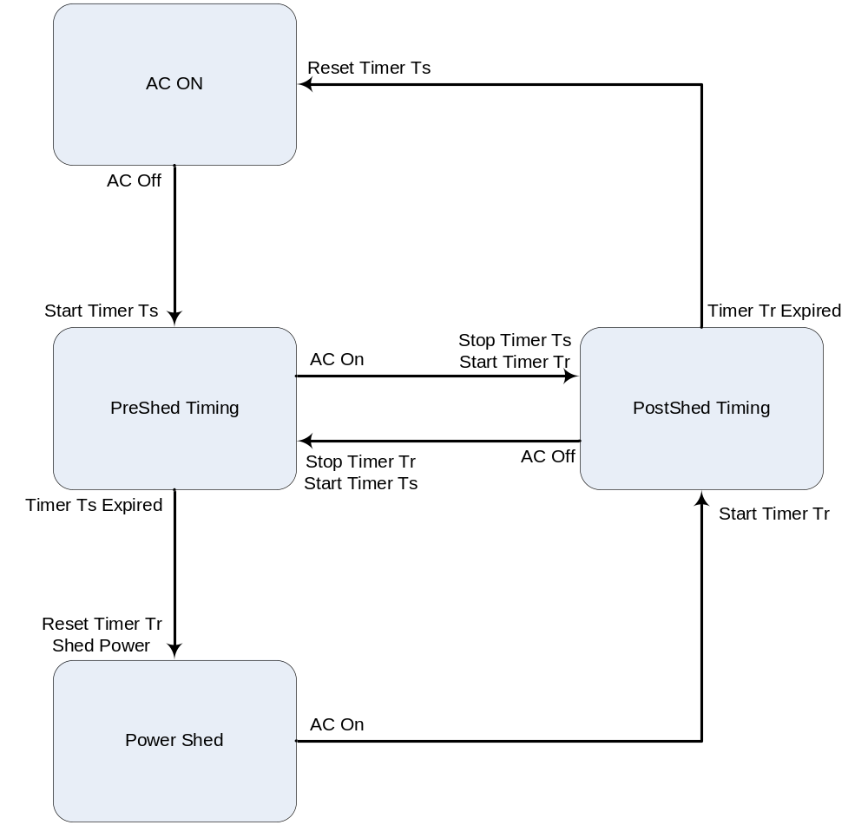

Figure 8.25 – Power Shedding State Diagram

Layer 2 Data Service

Requirements Base
<Provides an overview of WT-156 and eventually references the resulting TR>
- WT-156 provides architectural and network element requirements to allow the use of GPON access nodes in the TR-101 access architecture.
- These requirements define a division of L2 functionality between the ONT and OLT.
- The requirements also define a GPON mapping scheme for T-CONT and GEM port usage.
- Only addresses “smaller” ONT types and not GPON fed DSLAMs. So WT156 addresses MDUs but not “large” MDUs. A “large” MDU is defined not by port count but more by position in the management domain…ie a large MDU will be managed by TR-069.
- Addresses 3 VLAN configurations:
  - N:1 VLAN…Many users per VID
  - 1:1 VLAN…One to one user port to VID
  - Transparent VLAN (TLS)
- Both tagged and untagged frames supported at U interface.
- Uses 802.1ad S-TAG/C-TAG definitions.TPID = 0x8a88 & TPID = 0x8100
- A GEM port can be mapped into a single T-CONT. Multiple GEM ports can be mapped to a single T-CONT.
- Upstream flows may be mapped to GEM ports based on user port plus P-Bits, VID, Ethernet Type or DSCP.
- ONT must support 4 CoS and 1 T-CONT per CoS.
- ONT must support Strict Priority Scheduling.
- ONT must support Drop Precedence on 2 CoS.

ANI Management

ANI Requirements Summary

ANI Data Model
<This section contains a description of the ANI data model including Alloc_IDs, T-CONTs, GEM Ports and queues. Included here would be recommended T-CONT, GEM port and priority queue counts.>

ANI Operation
<This section provides a description of how the data model described in 3.1 is used>

Layer 2 Unicast Data Services

Unicast Requirements Summary

- N:1 VLANs:
  - ONT always adds an S-Tag or translates an incoming S-Tag on upstream traffic.
  - OLT uses the S-Tag + MAC + priority bits to determine downstream GEM port.
  - ONT removes or translates the S-Tag on downstream traffic.
- 1:1 VLANs:
  - Each U interface is mapped into a single VLAN.
  - May be single or double tagged at the V interface.
  - ONT always adds a tag or translates a tag on incoming frames at the U interface.
  - If frames are double tagged at the V interface, the ONT adds or translates to a C-Tag and the OLT adds the S-Tag.
  - If frames are single tagged at the V interface, the ONT adds or translates to an S-Tag and the OLT passes through the tag.
  - Downstream is opposite operation.
- Transparent LAN Service (TLS):
  - Traffic may be single tagged, double tagged, untagged or priority tagged at the U interface.
  - The ONT adds or translates to an S-Tag on upstream frames.
  - The OLT passes the S-Tag through.

Service Delivery Provisioning Models
<This section contains delivery provisioning models based on the preferred implementation of the FSAN vendor community. There will be a minimum of 1 model per use case defined in section 4.1. There may also be multiple models per use case but the model used by the majority of vendors will be designated as the primary model with the remaining models designated as secondary.>

Layer 2 Multicast Data Services

Multicast Requirements Summary
<This section contains use cases provided by the FSAN operator community>

Service Delivery Provisioning Models
<This section contains delivery provisioning models based on the preferred implementation of the FSAN vendor community. There will be a minimum of 1 model per use case defined in section 5.1. There may also be multiple models per use case but the model used by the majority of vendors will be designated as the primary model with the remaining models designated as secondary.>

Layer 3 Data Services
<This section describes the use of the IP host services data model. This section may also describe the use of the IP Router data model if it is not deprecated in G.984.4>

Ethernet Services
<This section describes the expected behavior of the Ethernet UNI and usage of the Ethernet services data model.>

802.11 Services
<This section may not be needed if 802.11 services is deprecated from G.984.4>

xDSL Services
<This section describes the expected behavior of xDSL interfaces and usage of the xDSL services data model.>

TDM Services

CES
<This section describes the expected behavior of the DS1 UNI and usage of the TDM services data model.>

Voice Services

VoIP Media Provisioning
<This section covers the provisioning of the VoIP Media Profile ME, Voice Service Profile AAL ME, and RTP Profile ME. It is referenced by the following sections.>

SIP OMCI Provisioned
<This section describes usage of the SIP OMCI model to provision SIP service. This includes the POTS provisioning but the Media provisioning is referenced to section 11.1>

SIP Non-OMCI Provisioned
<This section describes usage of the SIP Config Portal model. This model is used when a management interface other than OMCI (ie TR-069) is used to provision SIP service.>

H.248 OMCI Provisioned
<This section describes usage of the H.248 OMCI model to provision SIP service. This includes the POTS provisioning but the Media provisioning is referenced to section 11.1>

H.248 Non-OMCI Provisioned
<This section describes usage of the SIP Config Portal model. This model is used when a management interface other than OMCI (ie TR-069) is used to provision SIP service.>

MoCA
<This section describes usage of OMCI to provision MoCA.>

Traffic Management
<This section identifies use cases for the two traffic management models (Priority Queuing and Traffic Scheduling). In addition, it describes the provisioning of each model.>

Alarms and AVCs
<This section clarifies overall alarm and AVC handling in the ONT>

Test Processing
<This section clarifies test request and response handling in the ONT>

Performance Monitoring
<This section clarifies overall performance monitoring in the ONT>

RF Overlay and Return
<This section describes provisioning and monitoring of RF Overlay and Return.

Vendor Specific Object Handling
<This describes the overall handling of vendor specific objects. This does not describe any vendor specific objects other than by of example.>

For Future Study

- Home networking interfaces
  - HPNA
  - Powerline
  - UWB

